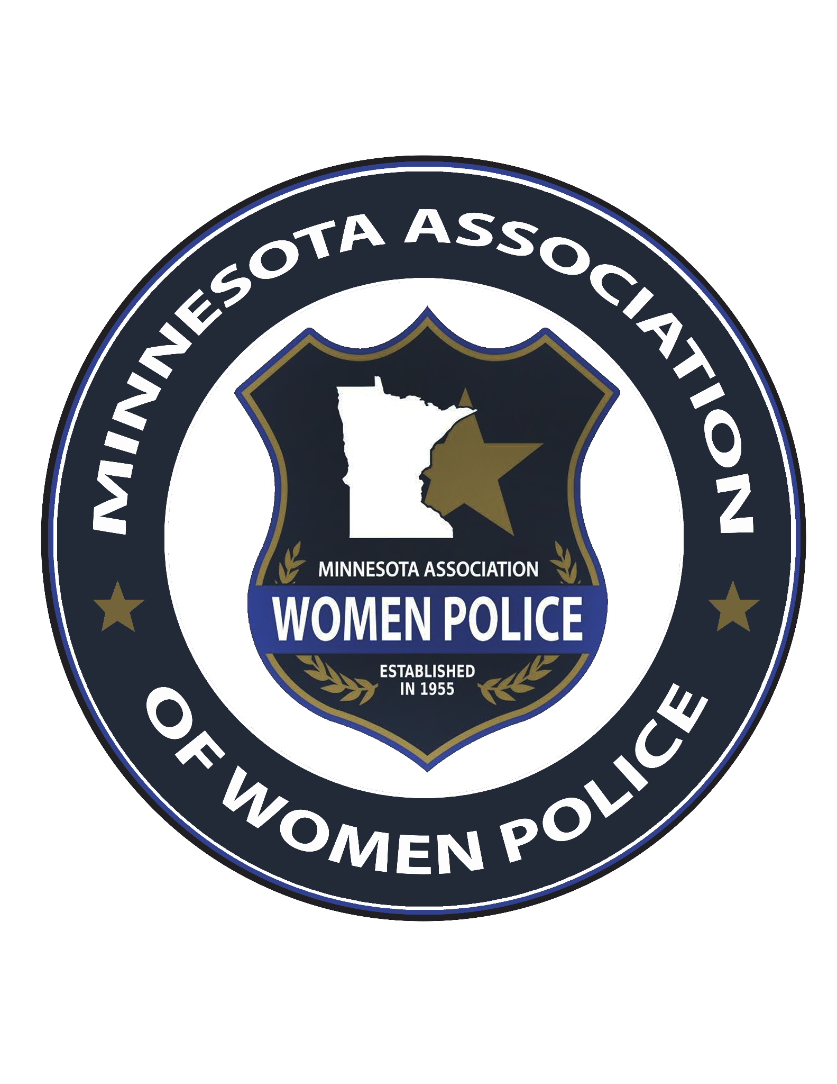

Board Meeting Minutes
Friday, February 27, 2026
Douglas County Water Safety Building
530 Willow Dr, Alexandria, MN 56308

Attendees: President Debora Ocloo, 1st Vice President Nicole Swanson, 2nd Vice President Brianna Kisch, Treasurer Amanda St. George, Historian Ashlee Langer, Communications Director Abby Mumme

1. Secretary Report (Presented by President Debora Ocloo on behalf of Secretary Christina)
- Continued progress is being made on the association clothing website.
2. Treasurer Report – Amanda St. George
- Checking account balance: approximately $18,000
- Savings account balance: approximately $23,000
Scholarship Update
- Five applications have been submitted.
- Amanda has continued communication with former board member Courtney Hartle to coordinate nomination selections.
- Hela Maurer of the Metro Transit Police Department has been invited to join the scholarship selection team. Confirmation is pending.
- An additional individual will be selected to assist with the process.
3. 1st Vice President Report – Nicole Swanson
Hospitality Event (Monday Evening)
- Mosaic activity planned with Artsy Fartsy.
- The board reviewed the email from Bonnie regarding costs.
- Nicole will follow up to confirm final attendance numbers needed.
- The board will determine how to gauge conference attendee interest.
Conference Hospitality Events
- Post-Awards Banquet networking will remain informal and open to all attendees.
- Sunday Night Early Check-In will include a “Casual Connections and Networking” dinner to allow attendees to connect with board members.
- Award nomination updates were discussed.
4. 2nd Vice President Report – Brianna Kisch
- Raffle Donations received, continuing to seek more donation items.
5. Old and New Business – President Debora Ocloo
Outreach
- Melvin Carter reached out to Debora and other affinity group presidents asking how she can support associations.
- Debora encouraged her to attend this year’s conference.
- Brianna shared that Mayor Carter is highly involved with the local police department.
Women’s Panel
- National Latino Peace Officers Association (NLPOA) requested promotion of their Women’s Panel.
- Topic focus: Empowered, Renewed, Grace, Resilient.
- March 26, 2026 | 1730–2100 hours
- Hennepin Technical College
Speaker Updates
- Crystal Kanada will no longer serve as the financial speaker.
- Rachel Carr will replace her.
- Jen Ellis was contacted and requested current events that would be impactful regarding moral injury.
- Board members were encouraged to suggest additional relevant topics.
Vendors
- Vendor applications continue to be received and processed for conference credit.
Minnesota All-Female Honor Guard
- Nine women have expressed interest in participating.
- Debora will notify LEMA that additional participants are no longer needed to post colors at the conference.
- Local law enforcement agencies have been responsive and will assist with a welcome.
Venue
- A complimentary conference room has been provided for board materials.
- A complimentary hotel room has also been provided.
POST Credits
- Debora continues working on POST credit submission.
- The goal is to obtain approval for 16 credits.
Conference Agenda
- The agenda has been finalized and will be posted on the website.
- Banquet attire: Board members are encouraged to wear their Class A uniforms if able.
- The updated agenda was reviewed and discussed by the board.
Promotional Video
- The promotional video was reviewed.
- It will be posted on social media.
- A thank-you message will be sent to Nicki for creating the video.
IAWP Membership
- The board requested an email outlining the benefits of remaining an affiliate/sister organization.
- Annual cost: $65 with submission of an annual report.
- Further discussion will determine whether to continue the partnership.
9. Next Meeting
- Final meeting prior to the conference will be held in April.
- Debora will send a scheduling poll to determine the date.

Meeting adjourned at 1915 hours (Motion by Abby Mumme; seconded by Brianna Kisch)

